You are going to build a project based on Library Management System. It keeps track of all information about books in the library, their cost, status and total number of books available in the library.  
  
Create a database named library and following TABLES in the database:   
  
1. Branch   
2. Employee   
3. Books  
4. Customer  
5. IssueStatus  
6. ReturnStatus

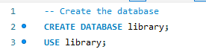  
  
Attributes for the tables:   
  
1. Branch  
  
• Branch_no

* Set as PRIMARY KEY    
  • Manager_Id    
  • Branch_address    
  • Contact_no

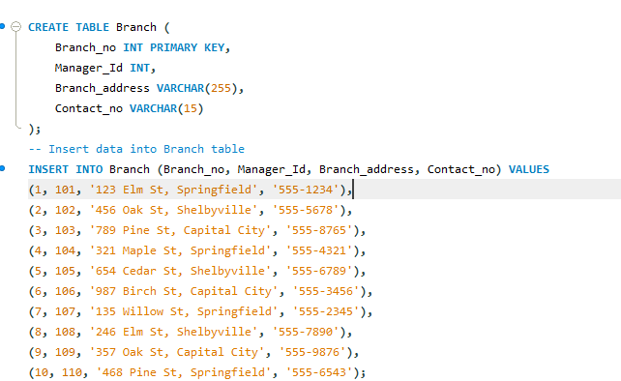

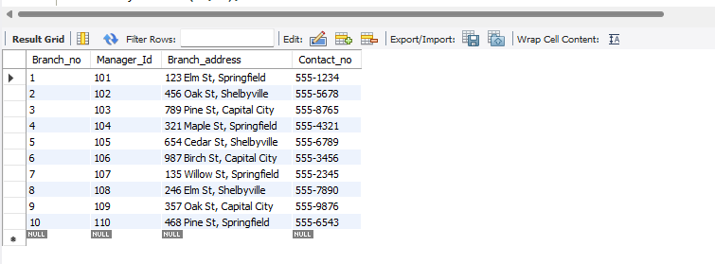

2. Employee    
  
• Emp_Id – Set as PRIMARY KEY    
• Emp_name    
• Position    
• Salary  
• Branch_no

* Set as FOREIGN KEY and it refer Branch_no in Branch table

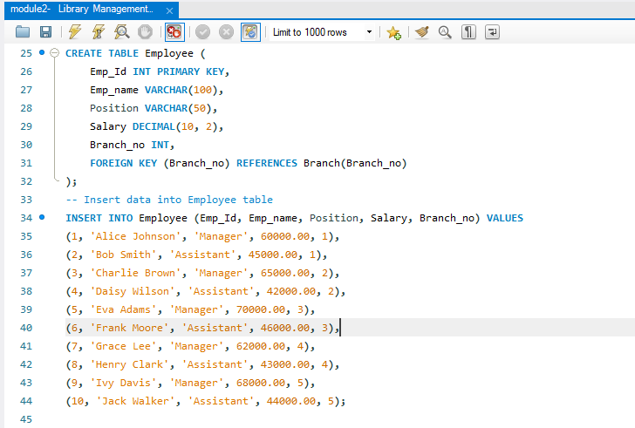

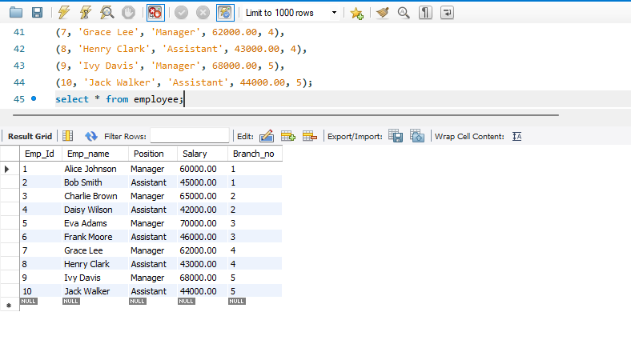

3. Books    
  
• ISBN

* Set as PRIMARY KEY    
  • Book_title    
  • Category    
  • Rental_Price    
  • Status [Give yes if book available and no if book not available]    
  • Author    
  • Publisher

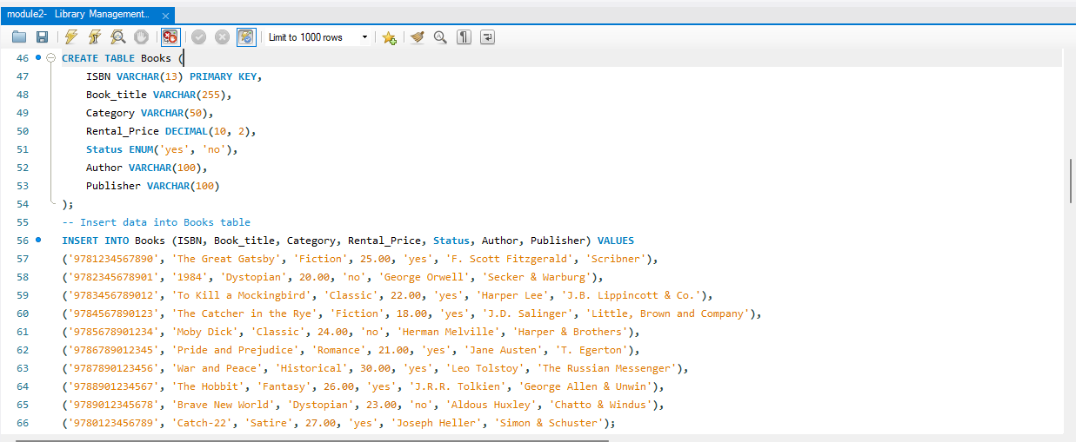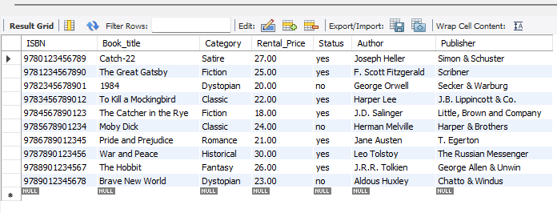

4. Customer    
  
• Customer_Id

* Set as PRIMARY KEY    
  • Customer_name    
  • Customer_address    
  • Reg_date

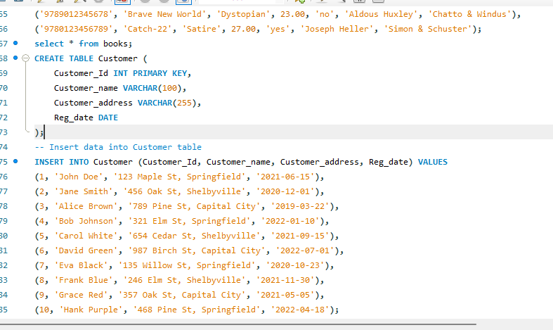

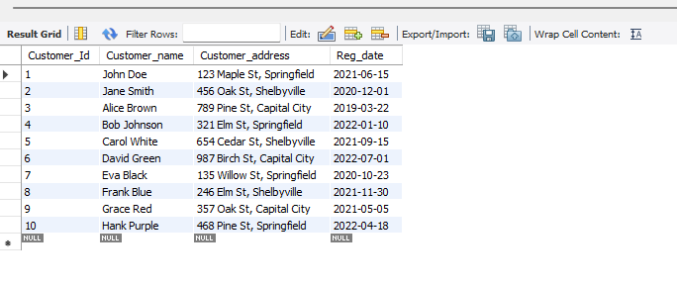

5. IssueStatus    
  
• Issue_Id

* Set as PRIMARY KEY    
  • Issued_cust – Set as FOREIGN KEY and it refer customer_id in CUSTOMER table  Issued_book_name   
  • Issue_date   
  • Isbn_book – Set as FOREIGN KEY and it should refer isbn in BOOKS table

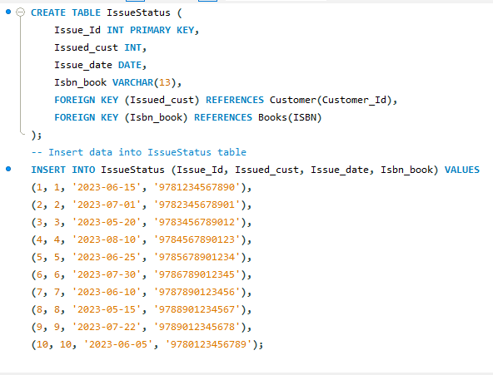

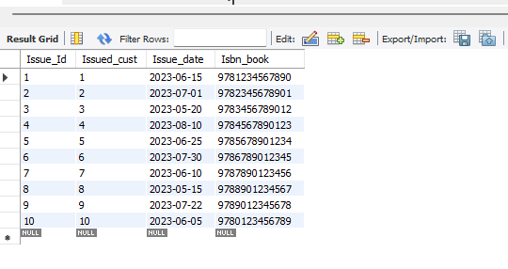

6. ReturnStatus    
  
• Return_Id

* Set as PRIMARY KEY    
  • Return_cust    
  • Return_book_name    
  • Return_date    
  • Isbn_book2
* Set as FOREIGN KEY and it should refer isbn in BOOKS table

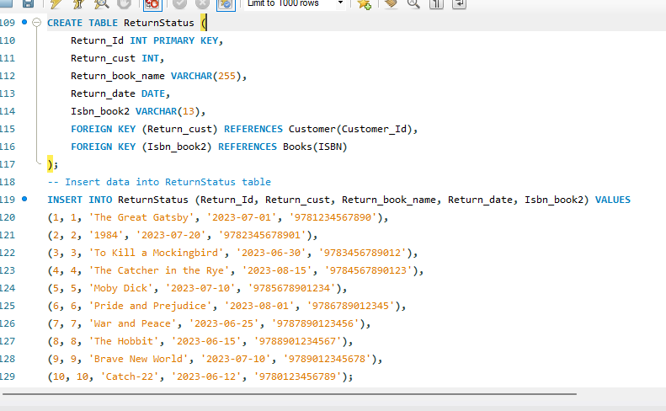

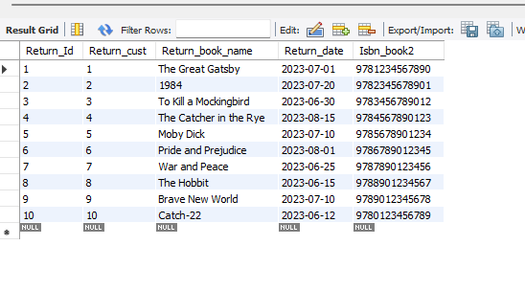

**QUESTIONS**

1. **Retrieve the book title, category, and rental price of all available books.**  
   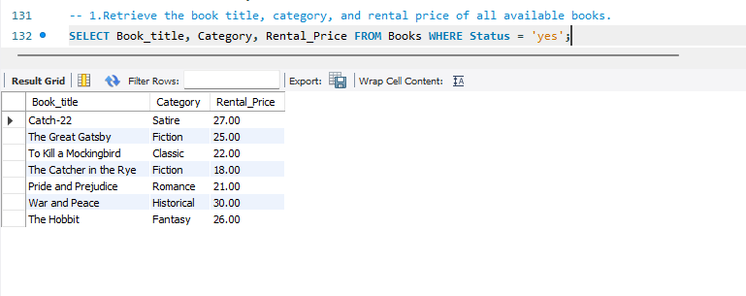
2. **List the employee names and their respective salaries in descending order of salary.**

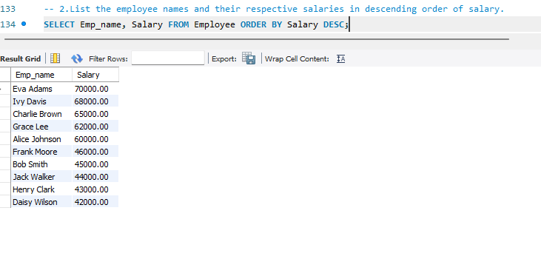

**3. Retrieve the book titles and the corresponding customers who have issued those books.**

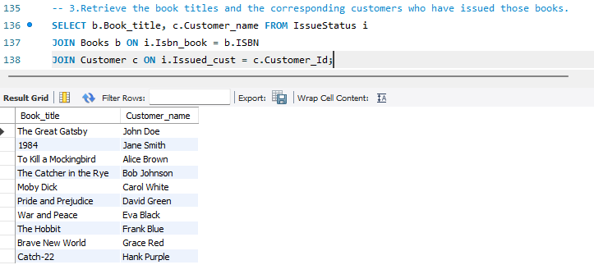  
**4. Display the total count of books in each category.**

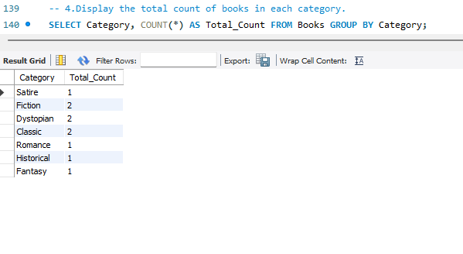

**5. Retrieve the employee names and their positions for the employees whose salaries are above Rs.50,000.**

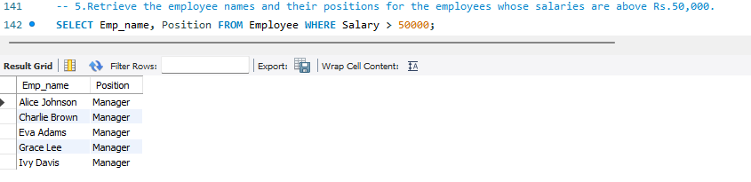

**6. List the customer names who registered before 2022-01-01 and have not issued any books yet.**

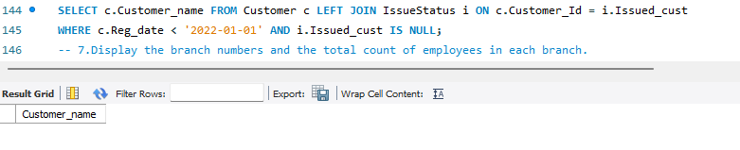 **7. Display the branch numbers and the total count of employees in each branch.**

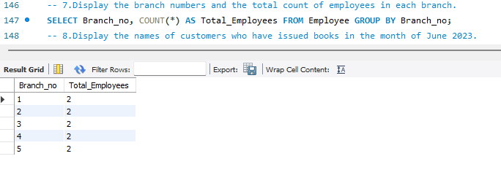

**8. Display the names of customers who have issued books in the month of June 2023.**

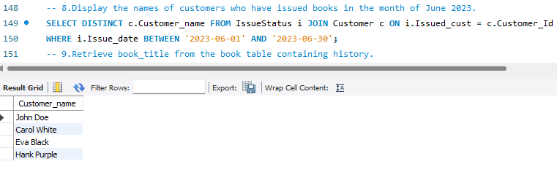  
**9. Retrieve book_title from book table containing history.**

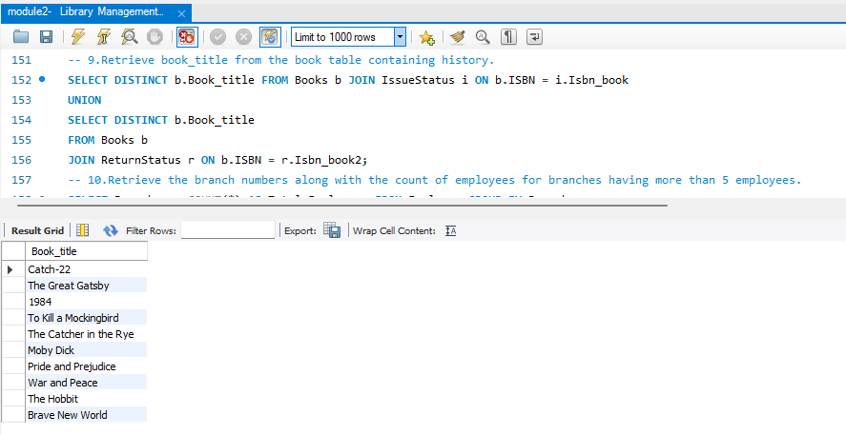 **10.Retrieve the branch numbers along with the count of employees for branches having more than 5 employees**

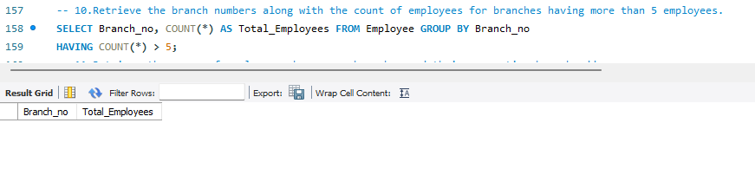  
**11. Retrieve the names of employees who manage branches and their respective branch addresses.**

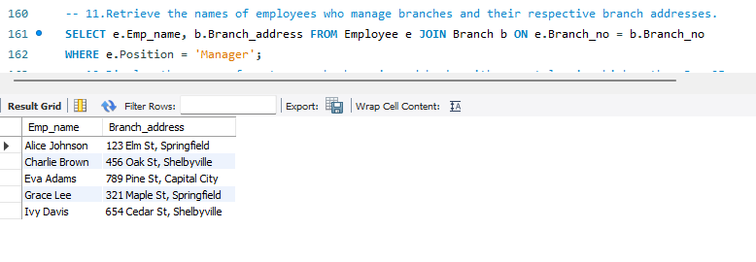 **12.  Display the names of customers who have issued books with a rental price higher than Rs. 25.**

